Project Management of Connect 4 Game Project

Group Members:

Bryan

Jeff

Fardin

Chris

Table of Contents

INitiation Phase/Project Charter

* Project Description
* Project SCope
* Measurable Goals
* Project Needs/Requirements
* Task List
* Deliverables
* Timeline

Planning/Development Phase

* Risk Management
* Detailed SCope
* Finalized List of Deliverables
* Changing of Schedule
* Gantt Chart (Project Schedule)

Algorithm

* GUI Interface
* AI Programming
* Win Conditions

Monitoring/Controlling Phase

* Checkpoints Being met
* Changes Made to Scheduling

**Initiation Phase/Project Charter**

Bryan, Fardin, Jeff, Chris

**Project Description**

Our task with this assignment is to code a GUI-based game of Connect 4 with various options for gameplay, and one of which is Player vs Player **or** Player vs AI. Other tasks includes writing about the components relative to Project Management, showing how we used it throughout the five stages in the development of our game.We are to divide up the workload as evenly as possible amongst our group members and ensure that everyone is contributing effort into this assignment.

**Project Scope**

Create a connect four game that gives the player the option to play against another player or an AI of varying difficulty.

**Measurable Goals**

* Create a code for a Connect 4 Game that meets all the requirements stated on the rubric provided at the beginning of the project
* Be able to use the Project Management processes in order to assist in the success of our project
* Meet the set due dates for certain tasks assigned within this project
* Be able to communicate effectively with other group members in order to ensure that all members are well informed as to the tasks in which they are to work on
* Collaborate with one another to work towards the successfulness of our coded game
* Add additional features to our coded Connect 4 Game to enrich the quality of the experience the users have

**Project Requirements**

In general, to achieve success in this project, the following requirements for our program must be met:

* detailed comments describing what each part of the program does
* proper formatting (indented correctly)
* must be in GUI format
* functioning variables
* must be easy to understand
* error free
* highly efficient (no redundant code)

**Task List (No Specific Order):**

The following tasks are to be coded

Player vs Player

Player vs AI

* Easy Mode
* Medium Mode
* Hard Mode

6 * 7 Grid

* 6 Rows
* 7 Columns

Two Different Pieces

* Either preset pieces to red and yellow or allow them to choose the colour
* Pieces will be o’s or we simply colour in the position of the grid

Allow Players to Enter their names

* Will replace the preset player 1 and player 2

Instructions Screen

Winning Message

* For rounds
* For game overall (if point limit was selected)

Counters for Points

* Max of 1 point per round
* Min of 0 points per round

Coin Flip to See Goes First

* One player will choose heads or tails
* Other player will automatically get the side that they didn’t choose
* Winner of coin toss will whether they will go 1st or 2nd
* Same thing goes for AI, if AI wins coin flip it will randomly generate a number between 1 and 2 to decide whether it will go 1st or 2nd

Checking Win Condition

* Begin checking after the player that went first, begins their 4th turn
* Check diagonal, horizontal, vertical

Placement of Pieces

* Users enter column number of which they would like to place a piece
* The piece will automatically go to the first unoccupied position of the column from the bottom up (use a boolean for the entire grid, set everything to false, when a piece is placed set equal to true)
* Check for first unoccupied spot of a column by using a reverse for loop that checks bottom up

Error messages

* Entry of invalid value heads/tails option for coin flip
* Entry of invalid column number
* Out of bounds, when user tries to place a piece in a column that is already filled up to the top
* Forces user to re-enter value

AI

* Easy

AI will place a piece randomly every 3 turns. Other turns it will calculate the best place to put a piece.

* Medium

AI will place a piece randomly every 5 turns. Other turns it will calculate the best place to put a piece.

* Hard

AI will place a piece randomly every 8 turns. Other turns it will calculate the best place to put a piece.

* Insane

AI will not place any pieces randomly, all placements will be calculated.

Switching of Turns

Checking of Score Condition

* Check 8 directions
* Top, Bottom, Top Right, Top Left, Bottom Right, Bottom Left, Right, Left
* Check in Pairs (Ex. Top Right & Bottom Left ), and if at least one is true continue checking in that direction

Other tasks include:

* Project management
* Algorithm
* Gantt Chart (recording our progress made each day)

**Deliverables:** The connect four game with all included features in the project requirements section, and proper documentation of the project management process.

**Timeline (Key Dates to Note):**

Project Given: December 21nd 2017

Project Charter Due: January 10th 2018

Algorithm and Planning Due: January 12th 2018

Monitoring and Controlling Due: December 21nd 2017 - January 18th 2018

Execution Due: January 12th 2018 - January 18th 2018

Closing Due: January 19th 2018

**Planning/Development Phase**

Bryan, Fardin, Jeff, Chris

**Risk Management**

**Risk:** Potential lack of time to complete a task

**Solution:** Ensure to always leave an extra day open just in case extra time is required (ex. takes an estimated 2 days to complete a task so mark down 3 days to complete it in the schedule -leaving the third day open just in case we need to extra time)

**Risk:** Errors in Code

**Solution:** Continue coding other things if you can’t solve it on the spot. Leave certain days for debugging the code in order to ensure that everything is working.

**Risk:** Person is busy with other tasks from other subjects so they are unable to do their assigned task within the timeline.

**Solution:** Always ensure that there is someone who can cover for that person and switch tasks with them. This will ensure that people will have the same amount of work, just the switching of what they do

**Detailed Scope**

Creation of a game of Connect 4, coded to be a GUI (Graphical User Interface). Code must be efficient, and must be fully functional. Required features includes: option for 2 Player or Player vs AI, AI of several difficulties, option for point limit for one side to win, 6 by 7 grid, game instructions, winning message, and various other important game options (stated in deliverables). We must also use project management to plan out everything that must be done in the various stages of projects (initiation, planning, executing, monitoring/controlling, and closing). Equal distribution of workload and tasks, with each task having a certain number of days to complete and always one extra day just in case it is needed.

**Finalized List of Deliverables**

The following is as to what is to be expected in our final code:

* must be in GUI format
* must be efficient and functional
* must be error free
* must be thoroughly commented for easy reader’s understanding
* properly formatted (indented properly)
* functioning variables
* various options for gameplay
* one player must be able to win
* display winning message

More specifically how our code should look:

**Home Screen**

* Have Buttons for instructions, player vs player mode, player vs ai mode
* AI level of difficulty (Easy, Medium, Hard)
* Option for point limit, if they choose to have a point limit then how many points (preset to 3 points)
* Option to exit the game (closes game window)

**Instructions Screen**

* Display instructions
* Back button to go back to home screen

**Game Screen**

* 6 by 7 grid
* Player’s scores at the bottom (if they choose to have a point limit)
* Display AI difficulty (if it Player vs AI)
* Give players an option to enter their name (otherwise its preset to Player 1 and Player 2)
* Chips of 2 colours (red and yellow)
* Players click buttons to place chips in column in which button is under (7 buttons)
* Winning message appears on screen
* Options to exit game (goes back to home screen)

**AI**

* Various levels of AI
* AI will determine best places to put its pieces
* Sometimes it will randomly place its pieces (depending on level of difficulty)

**Changing of Schedule**

In the event that we may have to change the schedule around due to some unexpected event. The following possible changes may happen:

* The switching of tasks between people
* Shifting of certain tasks forwards or backwards by 1 or 2 days
* Tasks losing or gaining the extra bumper day

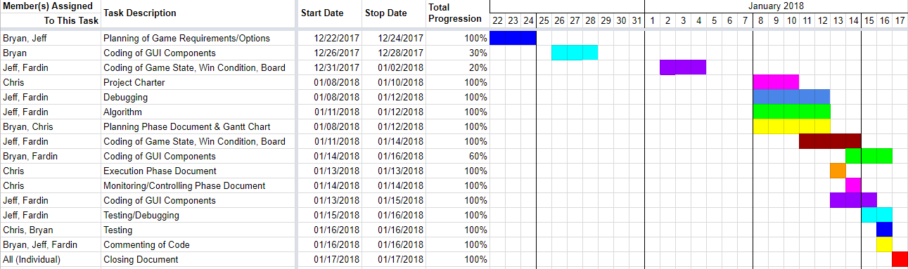

**Monitoring/Controlling Phase**

Bryan, Fardin, Jeff, Chris

**Checkpoints Being Met**

**Group Member(s):** Bryan, Jeff, Chris

**Date of Completion:** 12/24/2017

**Scheduled Date for Completion:** 12/24/2017

**Task:** Planning of Game Requirements/Options

**Documentation/Validification (Screenshots of Work):**

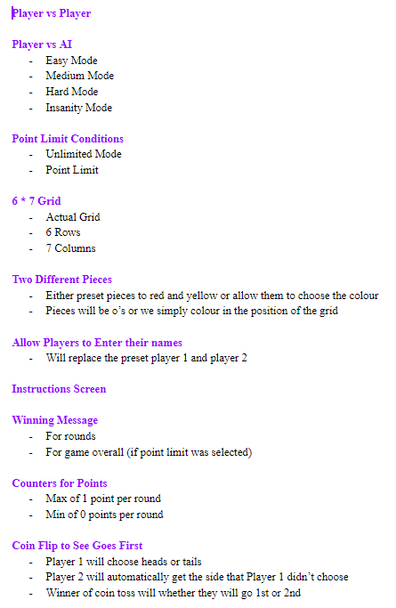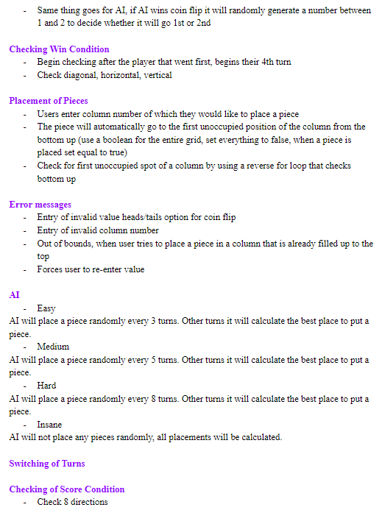

**Group Member(s):** Bryan

**Date of Completion:** 12/28/2017

**Scheduled Date for Completion:** 12/28/2017

**Task:** Coding of GUI Components (30%)

**Documentation/Validification (Screenshots of Work):**

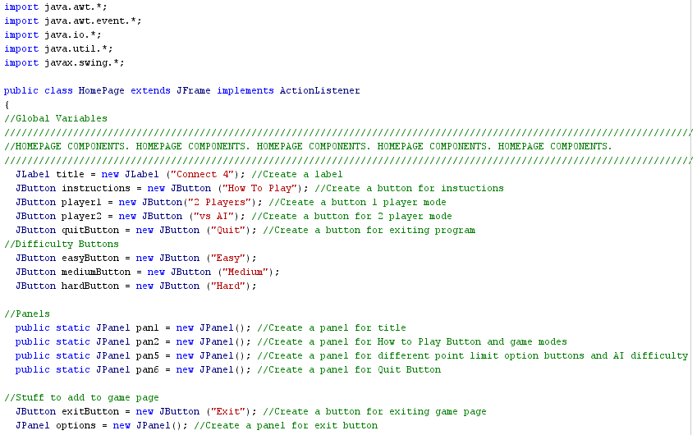

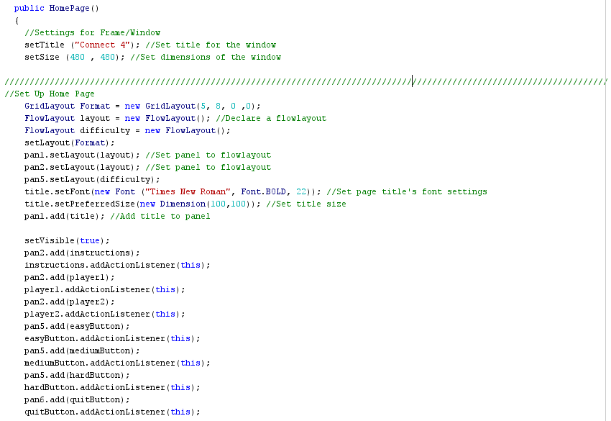

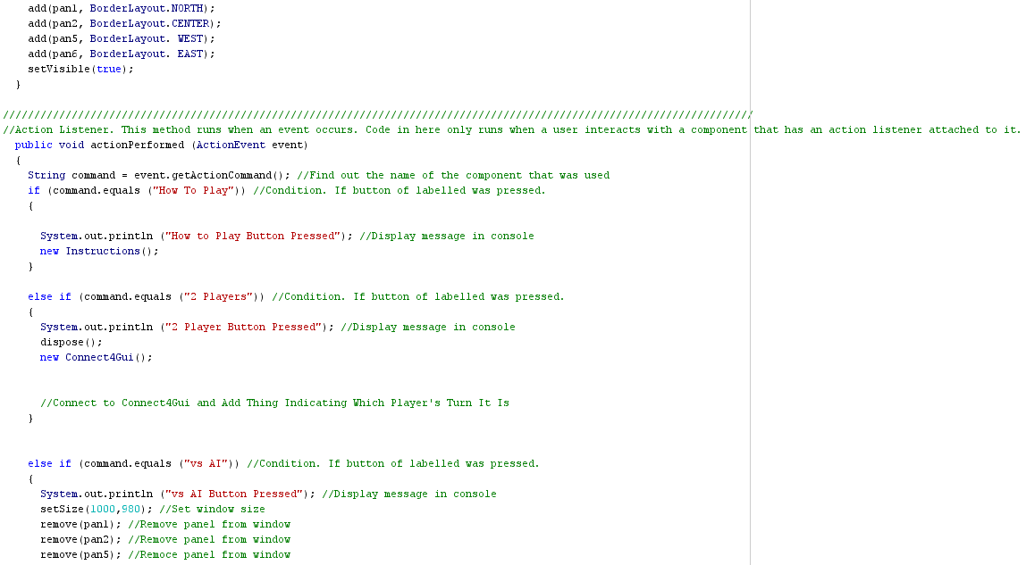

**Group Member(s):** Jeff, Fardin

**Date of Completion:** 01/02/2017

**Scheduled Date for Completion:** 01/02/2018

**Task:** Coding of Game State, Win Condition, Board (20%)

**Documentation/Validification (Screenshots of Work):**

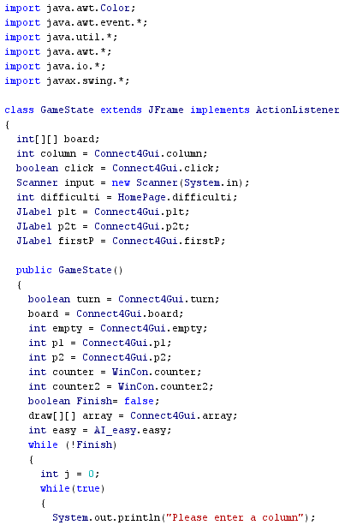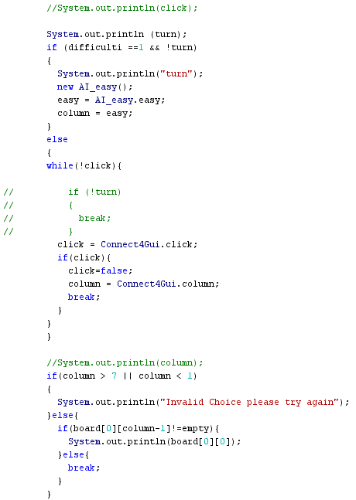

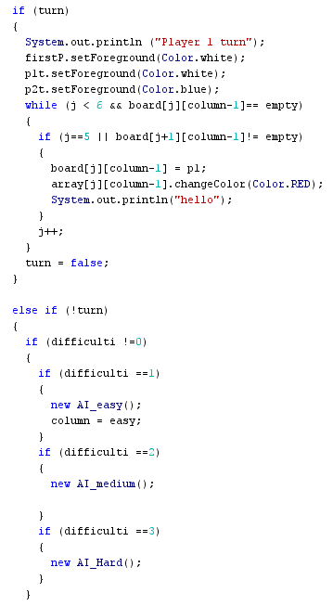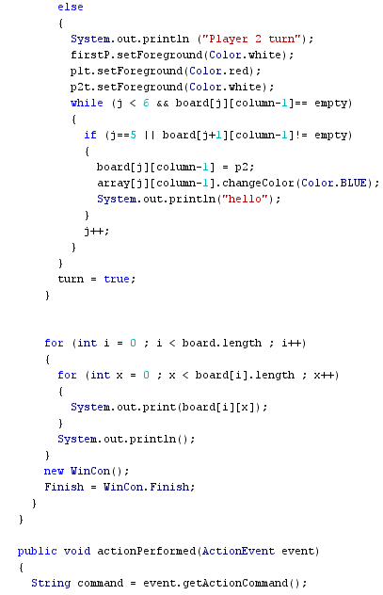

**Group Member(s):** Chris

**Date of Completion:** 01/10/2018

**Scheduled Date for Completion:** 01/10/2018

**Task:** Project Charter

**Documentation/Validification (Screenshots of Work):**

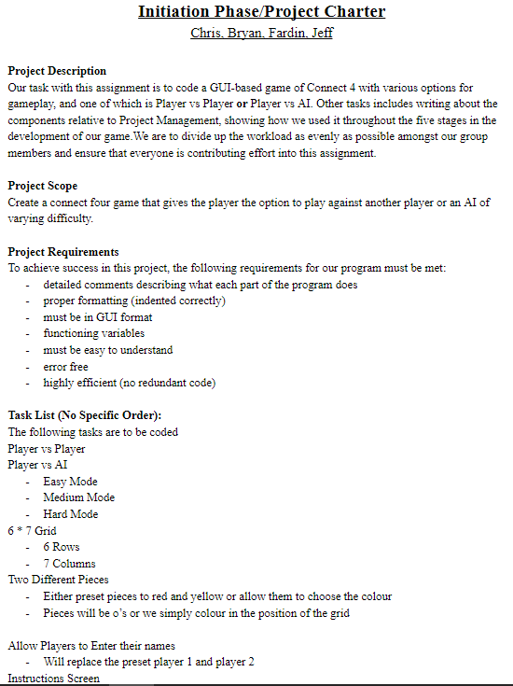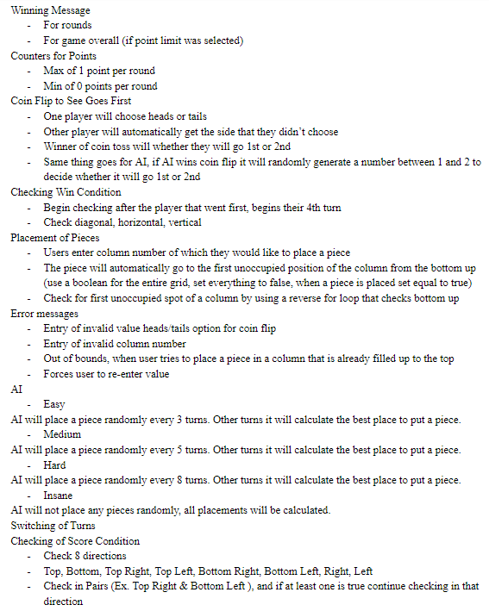

**Group Member(s):** Jeff, Fardin

**Date of Completion:** 01/12/2018

**Scheduled Date for Completion:** 01/12/2018

**Task:** Debugging of Issues Within Code

**Documentation/Validification (Screenshots of Work):** N/A

**Group Member(s):** Jeff, Fardin

**Date of Completion:** 01/11/2018

**Scheduled Date for Completion:** 01/12/2018

**Task:** Algorithm

**Documentation/Validification (Screenshots of Work):**

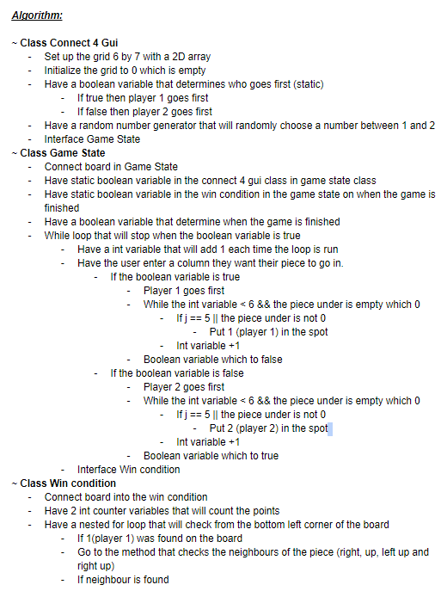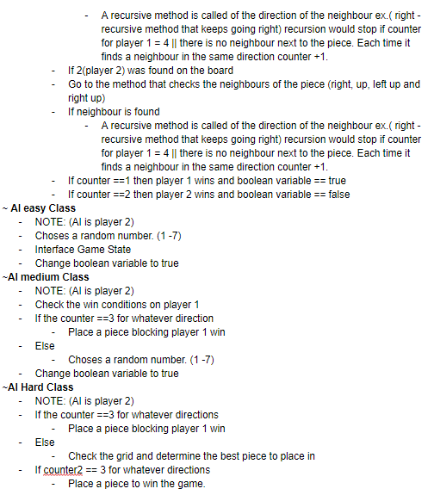

**Group Member(s):** Bryan, Chris

**Date of Completion:** 01/12/2018

**Scheduled Date for Completion:** 01/12/2018

**Task:** Planning Phase Document & Gantt Chart

**Documentation/Validification (Screenshots of Work):**

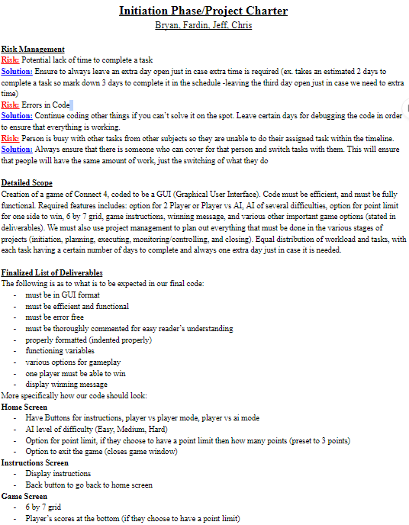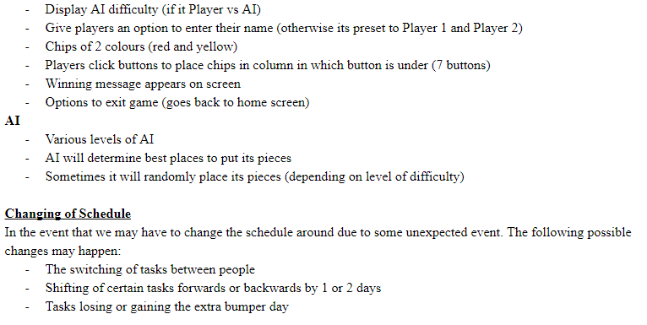



**Group Member(s):** Jeff, Fardin

**Date of Completion:** 01/18/2018

**Scheduled Date for Completion:** 01/18/2018 (Changed from 01/14/2018)

**Task:** Coding of Game State, Win Condition, Board

**Documentation/Validification (Screenshots of Work):**

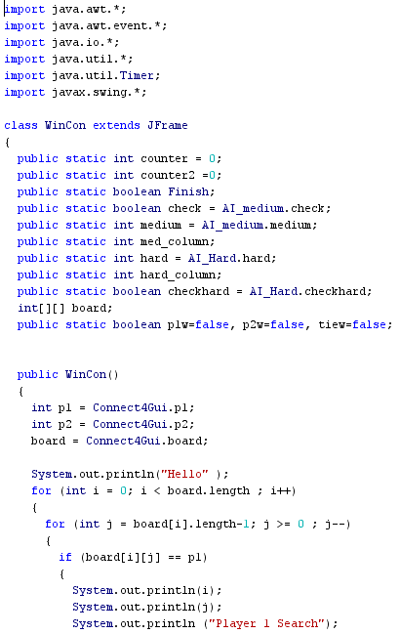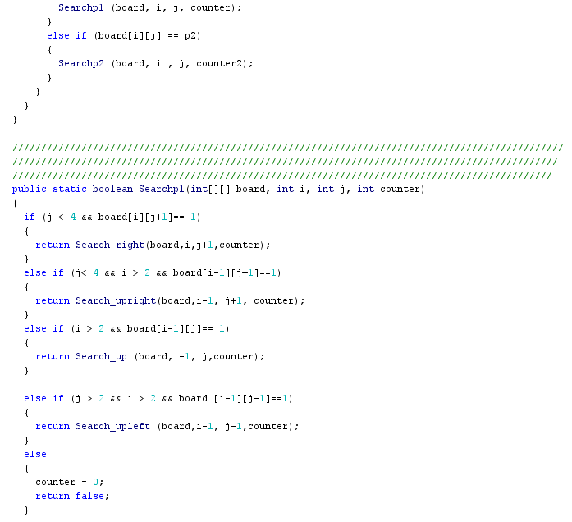**\**

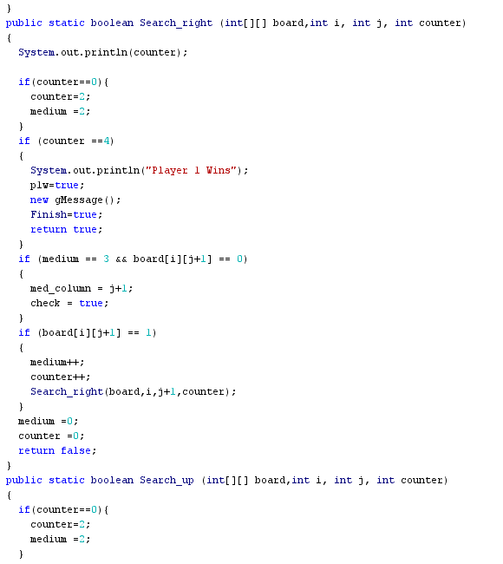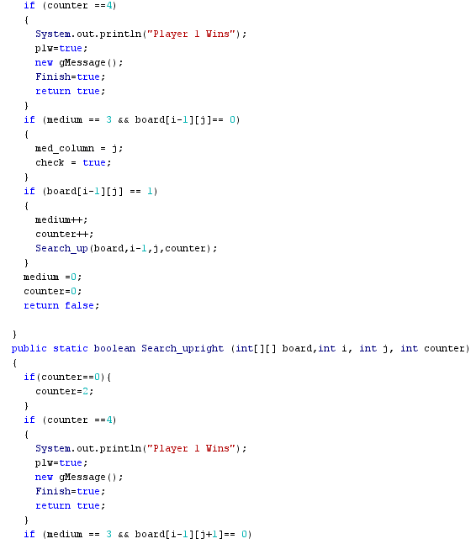

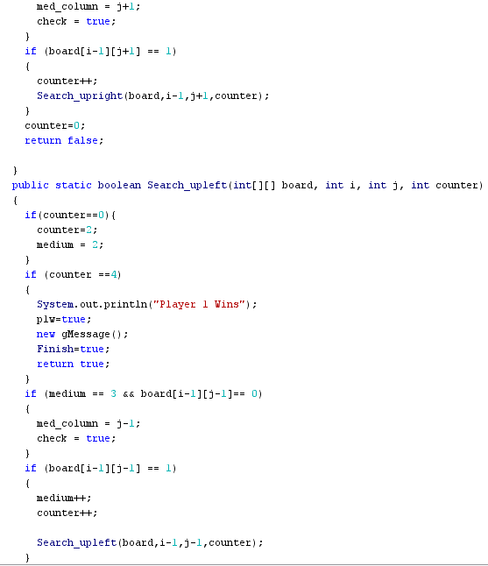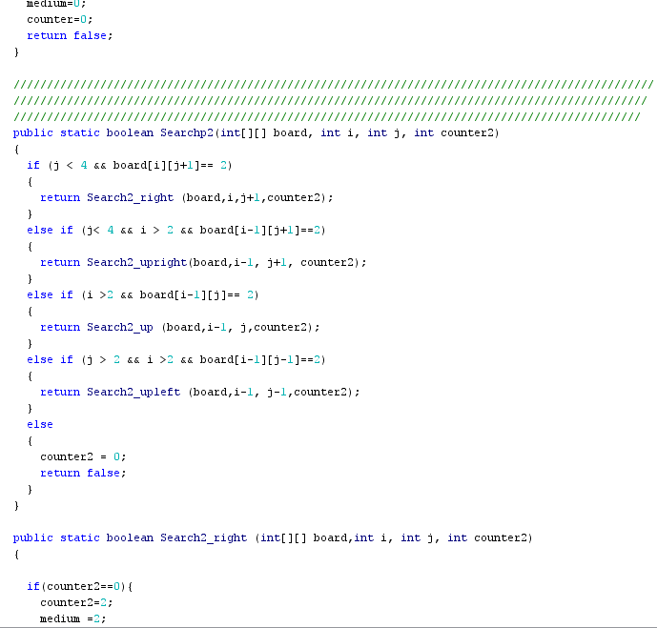

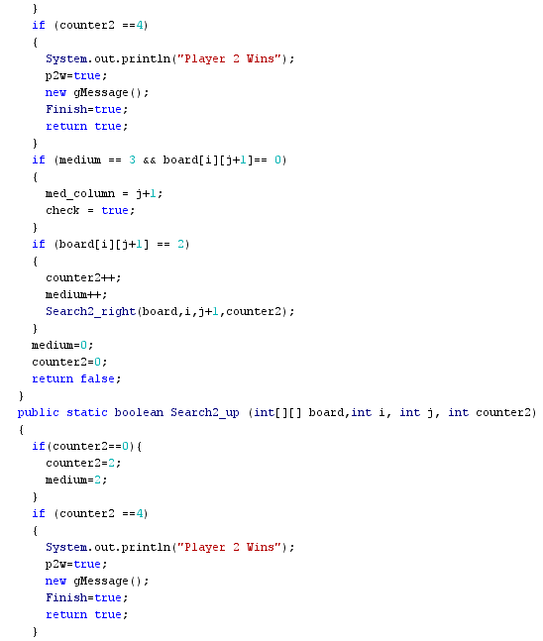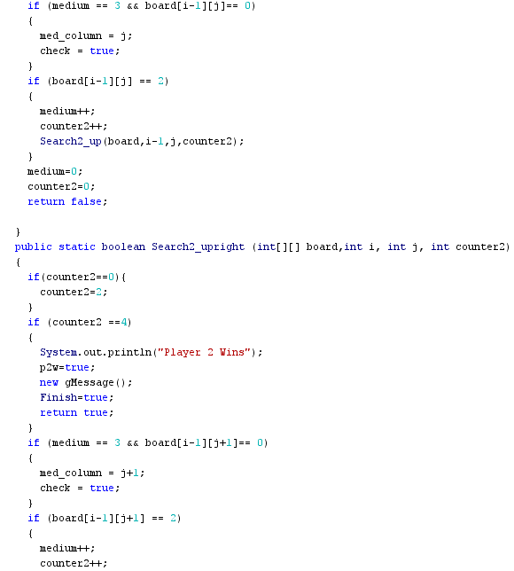

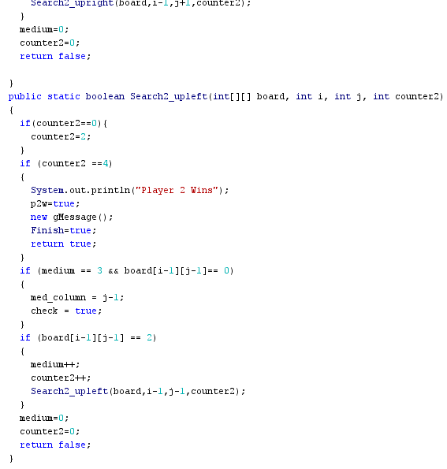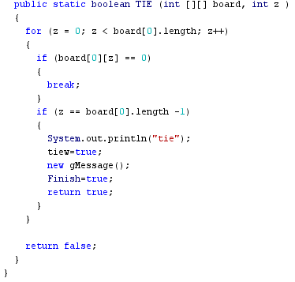

**Group Member(s):** Bryan, Fardin

**Date of Completion:** 01/17/2018

**Scheduled Date for Completion:** 01/17/2018 (Changed from 01/16/2018)

**Task:** Coding of GUI Components (60%)

**Documentation/Validification (Screenshots of Work):**

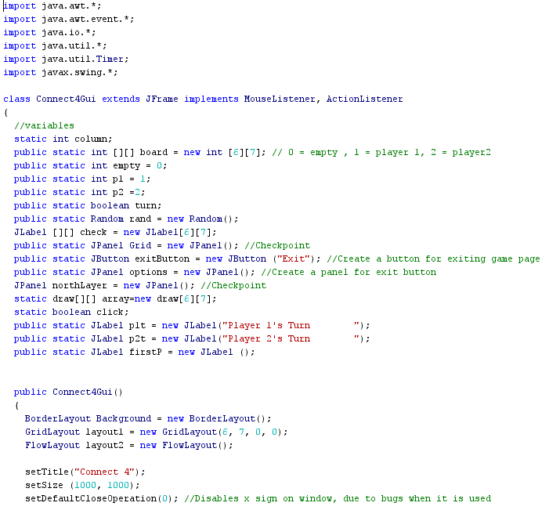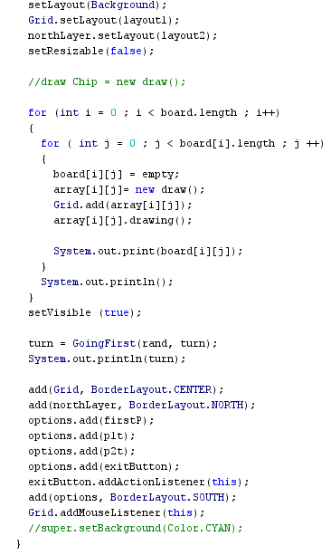

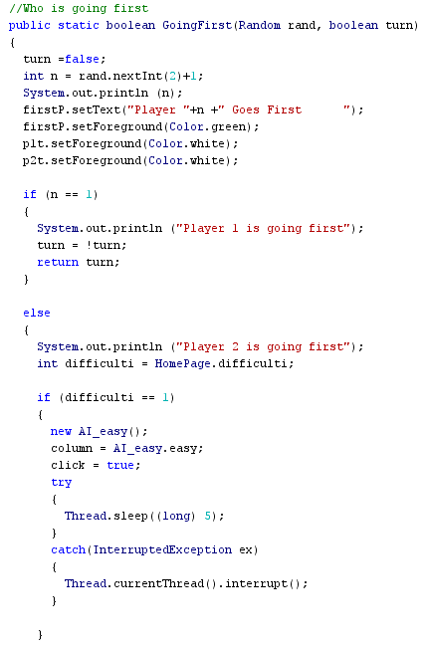

**Group Member(s):** Bryan

**Date of Completion:** N/A

**Scheduled Date for Completion:** N/A

**Task:** Execution Phase Document (Not Required, Done Through the Creation of Our Deliverable)

**Documentation/Validification (Screenshots of Work):** N/A

**Group Member(s):** Bryan, Chris

**Date of Completion:** 01/17/2018

**Scheduled Date for Completion:** 01/17/2018 (Changed from 01/14/2018)

**Task:** Monitoring/Controlling Phase Document

**Documentation/Validification (Screenshots of Work):** You’re Looking At It!!!

**Group Member(s):** Jeff, Bryan

**Date of Completion:** 01/18/2018

**Scheduled Date for Completion:** 01/18/2018 (Changed from 01/15/2018)

**Task:** Coding of GUI Components

**Documentation/Validification (Screenshots of Work):**

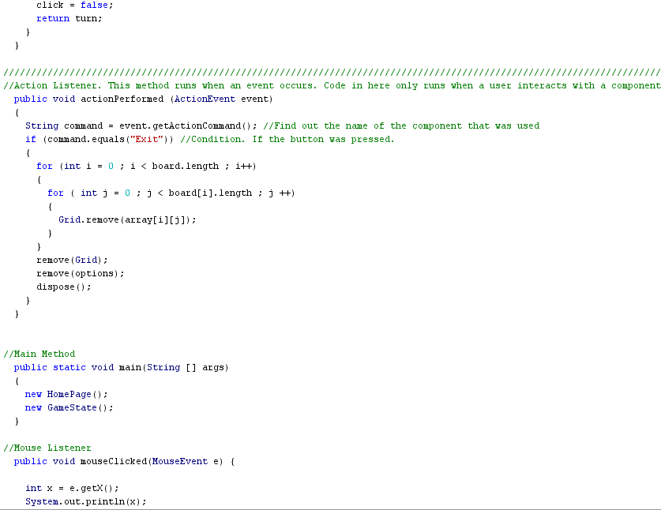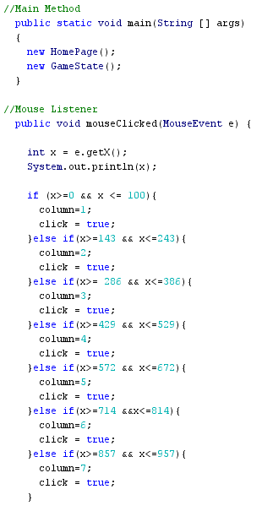

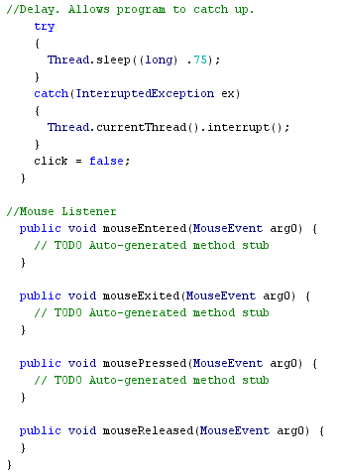

**Group Member(s):** Jeff, Fardin

**Date of Completion:** 01/19/2018

**Scheduled Date for Completion:** 01/19/2018 (Changed from 01/16/2018)

**Task:** Testing/Debugging

**Documentation/Validification (Screenshots of Work):** N/A

**Group Member(s):** Bryan, Chris

**Date of Completion:** 01/19/2018

**Scheduled Date for Completion:** 01/19/2018 (Changed from 01/16/2018)

**Task:** Testing

**Documentation/Validification (Screenshots of Work):** N/A

**Group Member(s):** Bryan, Jeff, Fardin

**Date of Completion:** 01/19/2018

**Scheduled Date for Completion:** 01/19/2018 (Changed from 01/16/2018)

**Task:** Commenting of Code

**Documentation/Validification (Screenshots of Work):** N/A

**Group Member(s):** Bryan, Jeff, Fardin, Chris (One Document Per Person; Individual)

**Date of Completion:** 01/19/2018

**Scheduled Date for Completion:** 01/19/2018 (Changed from 01/18/2018)

**Task:** Closing Document

**Documentation/Validification (Screenshots of Work):**

**Changes Made to Schedule**

**Request for Change:** Shifting of Due Dates By 2 Days (Due to Change in Amount of Time Given for Project)

**Impact Analysis:** Extra Time Allotted for All Tasks

**Approve/Deny:** Approve

**Review/Reporting:** Still on Schedule